ERD Lateralisation Selectivity as a Cross-Population Predictor of MI-BCI Neuroplasticity: Multi-Dataset Validation Across Healthy and Stroke Populations
Sanchit Dhanda^{1†}, Jugal Kishore^{2†}, Anjum Khan¹, Mariam Kacheishvili¹, Mzia Zhvania^{3,4}, Jyoti Mishra ^{5,6,7*}
1. David Tvildiani Medical University, Tbilisi, Georgia
2. Faculty of Medicine, Georgian National University SEU, Tbilisi, Georgia.
3. Laboratory of Neuron Ultrastructure and Nanoarchitecture, Ivane Beritashvili Center of
Experimental Biomedicine, Tbilisi, Georgia
4. School of Natural Sciences and Medicine, Ilia State University, Tbilisi 0162, Georgia
5. Neural Engineering and Translation Labs (NEATLabs), University of California, San Diego, 9500 Gilman Drive, Mail Code 0737, La Jolla, CA 92037, USA.
6. Department of Psychiatry, University of California, San Diego, La Jolla, CA, USA.
7. Center of Excellence for Stress and Mental Health, VA San Diego Medical Center, San Diego, CA, USA.
* Corresponding Authors: jymishra@ucsd.edu
† These authors contributed equally to this work and share first authorship

Abstract:
Background: Motor imagery brain-computer interfaces (MI-BCI) induce activity-dependent neuroplasticity with established clinical efficacy in post-stroke rehabilitation. However, event-related desynchronization (ERD) magnitude — the standard marker of cortical engagement — does not reliably track neuroplastic outcomes. The field lacks a validated EEG-based predictor of hemispheric reorganisation that generalises across populations.
Objective: To identify which candidate EEG predictors best explain variance in the change in hemispheric laterality index (ΔLI) beyond raw ERD magnitude, and to test cross-population validity across independent healthy and stroke cohorts.
Methods: EEG data from 272 unique participants (308 session-level observations) across five independent MI-BCI datasets — PhysioNet EEGMMIDB (n=108), Cho 2017 (n=52), BCI Competition IV-2b (9 subjects × 5 sessions), Lee 2019 (n=53), and Liu 2024 acute stroke (n=50) — were analysed using a unified preprocessing pipeline (MOABB, 160 Hz, C3/Cz/C4). Five candidate predictors were tested. ΔLI was treated as a continuous neuroplasticity measure throughout, consistent with recent critiques of binary BCI responder classification.
Results: ERD lateralisation selectivity — the rate of lateralised ERD growth over training, distinct from static laterality — emerged as the dominant predictor of ΔLI across all five datasets (Spearman ρ = 0.76–0.96; all p < 10⁻⁴; all surviving Bonferroni correction at 100 tests). Bilateral ERD slope was universally null (all |ρ| < 0.20). Two candidates were invalidated. Cross-band analysis confirmed frequency-specificity, ruling out mathematical coupling. A gradient-boosting model trained on healthy subjects predicted stroke responder status with AUC = 0.92 (sensitivity = 0.97, specificity = 0.67). NIHSS predicted lower selectivity for the left-hand imagery task (T1), which engages the contralesional hemisphere in right-hemiplegia patients (ρ = −0.436, p = 0.002 overall; ρ = −0.543, p = 0.009 in right-hemiplegia).
Conclusions: ERD lateralisation selectivity is a directly measurable, cross-population predictor of MI-BCI neuroplasticity. It is mechanistically distinct from static laterality (which does not predict ΔLI), transfers to stroke with preserved coupling, and provides a framework for selectivity-focused rehabilitation dosing.
Keywords: motor imagery, brain-computer interface, neuroplasticity, ERD lateralisation, stroke rehabilitation, dose-response, hemispheric reorganisation

1. Introduction
1.1 The molecular basis of MI-BCI neuroplasticity
Motor imagery (MI) engages overlapping but not identical cortical networks to overt movement, activating primary motor cortex (M1), premotor cortex, and supplementary motor area through descending motor planning pathways that do not cross the corticospinal execution threshold.^{1,2,6} MI produces event-related desynchronization (ERD) in the sensorimotor μ-band (8–13 Hz) and β-band (13–30 Hz), reflecting disinhibition of task-relevant cortical populations.¹ When sustained across repeated training, this cortical activation engages the canonical synaptic plasticity cascade — NMDA receptor-mediated calcium influx, CaMKII autophosphorylation, AMPA receptor insertion, and BDNF-dependent spine stabilisation.^{17,18,19,43,44} Brain-computer interfaces that provide real-time feedback contingent on MI-induced ERD amplify this plasticity loop.^{2,7}
1.2 Neuroplasticity after stroke: the rehabilitation gap
Meta-analytic evidence confirms that MI-BCI training produces clinically meaningful improvements in upper-limb motor function in post-stroke rehabilitation,^{4,5,9,13,14,22} and the Pichiorri et al. (2015) RCT demonstrated that BCI-supported MI practice significantly outperformed MI alone.⁷ Yet the stroke brain presents distinct neuroplastic challenges. Lesion-mediated disruption of corticospinal projections reduces the cortical territory available for reorganisation, and interhemispheric inhibitory imbalances alter the molecular environment for LTP induction. The result is a population in which 15–30% of patients show no benefit despite adequate training exposure,^{3,8} a rate stubbornly consistent across trials.
Importantly, the BCI 'inefficiency' rate depends heavily on the metric and threshold used. The conventional criterion of ≥70% binary command-decoding accuracy (the proportion of trials in which the BCI correctly classifies the user's intended movement)³⁰,³¹ has been critiqued as paradigm- and decoder-dependent rather than reflecting intrinsic neurophysiology and large-scale screening reveals the true proportion may reach 40–50%.^{31,34,24} No consensus ΔLI-based threshold exists.

1.3 The measurement problem: ERD ≠ reorganization
A central obstacle is the reliance on ERD magnitude as the primary marker of MI-BCI-induced plasticity. ERD indexes cortical activation, but activation and reorganisation are mechanistically distinct. The molecular cascade underlying reorganisation requires not merely strong activation but selective contralateral activation sustained with sufficient precision.^{16,17,20} If ERD does not capture this selectivity, dose-response analyses built on ERD will appear null — not because plasticity is absent, but because it is being measured with an insensitive instrument.
Prior work has established that hemispheric laterality relates to MI-BCI outcomes: fMRI laterality index change correlated with Fugl-Meyer improvement in a chronic stroke RCT (Ramos-Murguialday et al., 2013),^{40,41} and structural MRI laterality predicted BCI classification accuracy in healthy adults (Kasahara et al., 2015).¹⁰ However, these studies measured static laterality at one or two timepoints — a snapshot of hemispheric balance, not the dynamic process of reorganisation. The critical unanswered question is not whether laterality correlates with outcomes (it does), but what determines whether laterality changes in the first place. The present study addresses this gap by identifying ERD lateralisation selectivity — the differential rate of contralateral versus bilateral ERD change across training — as the measurable predictor of ΔLI. Selectivity captures the training-dependent process that drives laterality change, rather than the static endpoint.
This represents a shift from measuring neuroplastic outcomes to identifying their mechanistic determinants. Prior work confirmed that fMRI laterality changes after BCI training; the present study identifies the EEG-measurable predictor that determines whether laterality will change. Ramos-Murguialday et al. showed that fMRI-LI change correlates with recovery;40,41 the present study explains why some patients' LI changes and others' does not: it is because their ERD is selective — lateralised to the contralateral hemisphere — rather than diffuse. No prior study has identified this mechanistic predictor or validated it across independent datasets.
1.4 The present study
We pursue five aims across 272 participants (308 session-level observations) in five datasets: (1) test whether ΔLI dissociates from ERD slope; (2) test which candidate EEG predictors best explain ΔLI variance, with the expectation that not all would survive multi-cohort validation; (3) characterise the dose-response dynamics of reorganisation — in particular its phasic, non-monotonic trajectory across training and the reversibility of gains when consolidation fails; (4) test cross-cohort replication including acute stroke; (5) anchor EEG metrics to clinical severity (NIHSS), stratified by hemiplegia side. Consistent with the field's move toward continuous metrics,³²,³³ ΔLI was treated as a continuous neuroplasticity measure throughout.

2. Methods
2.1 Datasets
Five publicly available MI-BCI EEG datasets were included (Table 1). These represent all MOABB-accessible left/right hand MI paradigms with ≥9 participants available at the time of analysis, eliminating selection bias in dataset choice. In total, 272 unique participants contributed 308 session-level observations: BCI-IV-2b contributed 9 participants across 5 sessions (45 observations); all other datasets contributed one observation per participant.
Dataset | Participants | Pop. | Paradigm | Sessions (obs.) | sfreq | Ch. | Role
PhysioNet² | 108 | Healthy | L/R hand MI | 1 (108) | 160 | 64 | Discovery
Cho 2017²⁵ | 52 | Healthy | L/R hand MI | 1 (52) | 512 | 64 | Confirmatory
BCI-IV-2b | 9 | Healthy | L/R hand MI | 5 (45) | 250 | 3 | Confirmatory
Lee 2019¹¹ | 53 | Healthy | L/R hand MI | 2 (53) | 1000 | 62 | Confirmatory
Liu 2024²⁷ | 50 | Stroke | L/R hand MI | 1 (50) | 500 | 30 | Clinical anchor
Total | 272 |  |  | 308 obs.

Table 1. Dataset characteristics. PhysioNet subject 88 excluded (128 Hz). Liu 2024 high-artefact subjects (n=13) included in primary analysis; sensitivity analysis reported. BCI-IV-2b: 9 unique participants contribute 45 session-level observations; mixed-effects analysis with random intercept for subject is reported in Supplementary Material.
2.2 Preprocessing and harmonization
Data were loaded through MOABB v1.5.²⁶ All recordings were resampled to 160 Hz, restricted to C3, Cz, C4, and epoched 0.0–3.0 s post-stimulus. Band-specific extraction used 2nd-order Butterworth zero-phase IIR filters (μ: 8–13 Hz; β: 13–30 Hz). ERD was computed as ERDdB = 10 × log₁₀(PMI/Pbaseline), baseline 0.0–0.5 s, MI 0.5–3.0 s (Welch's method). Epochs exceeding 250 μV were rejected.

2.3 Task-relative laterality index
ΔLI and the three-stage (early/mid/late) framework were developed exploratorily on the PhysioNet discovery cohort; the remaining four datasets served as independent confirmatory replications, with identical metric definitions and analysis applied without further tuning.
LI = (|ERDcontra| − |ERDipsi|) / (|ERDcontra| + |ERDipsi|)
Positive LI indicates contralateral dominance. Training stages were operationalised by partitioning clean epochs into equal-sized early, mid, and late thirds. ΔLI = LIlate − LIearly. ΔLI was treated as a continuous measure throughout; for descriptive phenotyping, participants showing ΔLI > 0 in at least one task were classified as positive-ΔLI for that band.
2.4 Candidate predictors
Five candidate predictors were derived from discovery-phase analysis on PhysioNet: (i) ERD selectivity — contralateral minus bilateral ERD slope across stages, measuring the rate of lateralised ERD growth (distinct from static LI, which measures baseline hemispheric balance); (ii) C3–C4 imaginary coherence and wPLI; (iii) Trial-level ERD CV; (iv) ERD onset latency SD; (v) μ–β band coordination.
2.5 Mathematical coupling controls
Because selectivity and ΔLI are both derived from C3/C4 ERD, five controls were implemented to rule out tautological coupling. First, hierarchical regression tested whether selectivity added variance beyond contralateral ERD slope alone (the shared input); a tautological relationship would produce ΔR² = 0. Second, cross-band analysis tested whether μ-selectivity predicted β-ΔLI: if the relationship were driven by mathematical structure, cross-band prediction should hold, but if it reflects genuine frequency-specific plasticity, it should fail. Third, leave-one-dataset-out (LODO) cross-validation tested out-of-sample prediction. Fourth, we directly compared selectivity against static laterality (mean LI across all trials): if selectivity merely recapitulated static hemispheric balance, the two should predict ΔLI equally. In fact, static LI showed no relationship with ΔLI (ρ = 0.09 in PhysioNet, ρ = −0.14 in Liu 2024), while selectivity predicted strongly (PhysioNet ρ = 0.84, Liu 2024 ρ = 0.81), confirming that the temporal dynamics of lateralisation — not its baseline level drive the association.
Fifth, we performed subject-label permutation to test whether the selectivity–ΔLI correlation could arise from shared mathematical structure: each subject's selectivity was paired with a randomly reassigned subject's ΔLI (5,000 permutations per dataset), preserving each metric's own distribution while destroying the within-subject correspondence. A tautological relationship would persist under mismatched pairing; a genuine within-subject coupling would collapse.
2.6 Statistical analysis
ERD measure–ΔLI associations were assessed by Spearman rank correlation. Hierarchical regression tested selectivity and coherence ΔR² beyond contralateral ERD slope. Dose-response models were compared by BIC. Machine-learning prediction used gradient boosting (5-fold stratified CV within-dataset; train-healthy/test-stroke cross-population). Clinical correlations (NIHSS) used Spearman ρ, stratified by hemiplegia side.
Multiple comparisons were controlled at two levels. Within each dataset's primary test battery (6 tests), Benjamini–Hochberg correction was applied at FDR = 0.05. Across the full analysis battery (>70 tests including 12 selectivity–ΔLI correlations, 12 bilateral null tests, 10 hierarchical regressions, and clinical correlations), the core selectivity finding was additionally assessed against global Bonferroni correction. All 12 selectivity–ΔLI correlations survived Bonferroni correction at 100 tests (weakest p = 5.0 × 10⁻¹¹; threshold p < 5.0 × 10⁻⁴).
2.7 ΔLI reliability and interpretation
ΔLI is a within-session measure of plasticity dynamics, not a stable trait. As such, high between-session variability is expected: session-level neuroplasticity reflects the interaction of training parameters, vigilance state, and prior learning history, all of which vary across sessions. In the BCI-IV-2b dataset (n=45 sessions), the ICC(3,1) for ΔLI was low (T1: 0.04; T2: −0.11), confirming substantial session-to-session variability. However, sign consistency — the proportion of sessions in which a participant's ΔLI maintained the same direction — was 0.71, indicating that participants who tend toward contralateral dominance shifts do so more often than not, even if the magnitude varies. ΔLI should therefore be interpreted as an index of session-level plasticity dynamics rather than a fixed participant characteristic, analogous to how heart rate variability measures autonomic dynamics rather than a fixed heart rate.
3. Results
3.1 ΔLI as continuous neuroplasticity measure
Positive ΔLI in both μ and β bands occurred in 62.8% of healthy observations and 48.0% of stroke subjects. Per-task positive-ΔLI rates ranged from 44–64%, consistent with chance-level fluctuation (binomial tests: all p > 0.05 in 10/10 comparisons), confirming that binary responder classification at the per-task ΔLI > 0 threshold lacks biological validity. Non-responder rates (negative ΔLI in both tasks, both bands) were 6.2% healthy and 8.0% stroke.
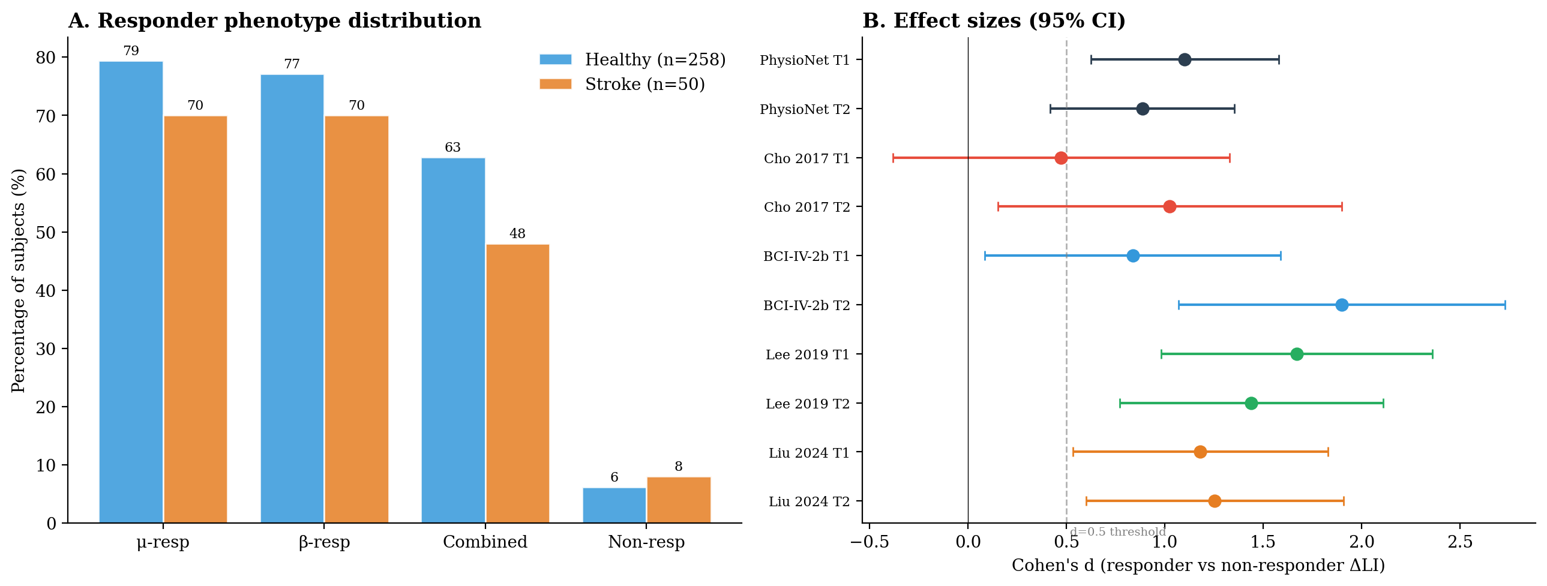
Figure 1. Responder phenotypes and effect sizes. (A) Proportion of subjects classified as μ-band responders, β-band responders, both bands combined, and non-responders, in healthy (n=258) versus stroke (n=50) cohorts. Combined positive-ΔLI rates were 63% in healthy participants and 48% in stroke; non-responder rates were 6% and 8%, respectively. (B) Forest plot of Cohen's d for the responder versus non-responder ΔLI contrast across all five datasets and both tasks (T1, left-hand imagery; T2, right-hand imagery), with 95% bootstrap confidence intervals. Effect sizes ranged from 0.47 to 1.90; the dashed line marks the d = 0.5 threshold. The single sub-threshold value (Cho 2017 T1) reflects extreme class imbalance (6 non-responders).

3.2 ERD selectivity as dominant predictor
ERD selectivity correlated with ΔLI at ρ ≥ 0.76 in every dataset and task combination (12/12 comparisons; range: 0.76–0.96; all p < 10⁻⁴; all surviving Bonferroni correction at 100 tests; Figure 2). Bilateral ERD slope was uncorrelated in every comparison (12/12 null; all |ρ| < 0.20; BCI-IV-2b T1 ρ = 0.20 was the borderline maximum). The strongest coupling was Liu 2024 T2 (ρ = 0.96) and Lee 2019 T1 (ρ = 0.90).
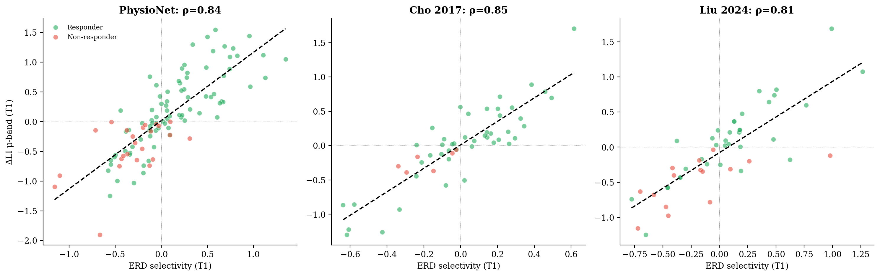
Figure 2. ERD lateralisation selectivity predicts ΔLI across populations. Scatter plots of μ-band selectivity against ΔLI for the left-hand task (T1) in three representative cohorts — PhysioNet (discovery, healthy), Cho 2017 (confirmatory, healthy), and Liu 2024 (acute stroke). Points are coloured by responder status; the dashed line is the least-squares fit. Spearman correlations (ρ = 0.84, 0.85, 0.81) were comparably strong in healthy and stroke cohorts, demonstrating cross-population generalisation of the selectivity–reorganisation relationship.
Critically, static laterality (mean LI averaged across training stages) did not predict ΔLI in any dataset (PhysioNet T1: ρ = 0.09; Liu 2024 T1: ρ = −0.14; both ns), whereas selectivity predicted strongly (ρ = 0.84, ρ = 0.81). This confirms that the temporal dynamics of lateralisation — how rapidly the contralateral-ipsilateral balance shifts during training — rather than its baseline level, drives the selectivity–ΔLI association.
Hierarchical regression confirmed selectivity explained 28–58% of ΔLI variance beyond contralateral ERD slope in all 10 dataset × task combinations (all F-change p < 10⁻⁵; Table 2). C3–C4 imaginary coherence added minimal variance (mean ΔR² = 0.013; significant in 1/10).
Dataset | Task | Step 1: ERD slope R² | Step 2: +Selectivity ΔR² | Step 3: +ImCoh ΔR² | Total R² | Within ρ
PhysioNet | T1 | 0.137 | +0.512*** | +0.000 | 0.650 | 0.838
PhysioNet | T2 | 0.110 | +0.525*** | +0.006 | 0.641 | 0.851
Cho 2017 | T1 | 0.183 | +0.581*** | +0.003 | 0.767 | 0.849
Cho 2017 | T2 | 0.040 | +0.413*** | +0.024 | 0.477 | 0.765
BCI-IV-2b | T1 | 0.363 | +0.360*** | +0.021 | 0.744 | 0.867
BCI-IV-2b | T2 | 0.355 | +0.275*** | +0.050* | 0.680 | 0.798
Lee 2019 | T1 | 0.320 | +0.467*** | +0.006 | 0.793 | 0.902
Lee 2019 | T2 | 0.065 | +0.494*** | +0.033 | 0.592 | 0.782
Liu 2024 | T1 | 0.316 | +0.336*** | +0.000 | 0.653 | 0.810
Liu 2024 | T2 | 0.448 | +0.445*** | +0.000 | 0.893 | 0.956
Table 2. Hierarchical regression and within-dataset correlations. ***p < 0.001; *p < 0.05.

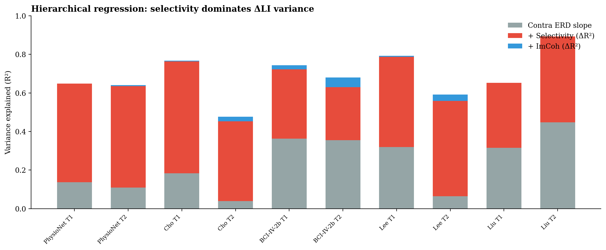
Figure 3. Hierarchical regression variance decomposition. Stacked bars show variance in ΔLI (R²) explained at each step across all ten dataset × task combinations: contralateral ERD slope alone (grey), the increment from adding ERD selectivity (red, ΔR²), and the increment from adding C3–C4 imaginary coherence (blue, ΔR²). Selectivity contributed 28–58% of ΔLI variance beyond ERD slope in every combination (all p < 10⁻⁵), whereas coherence added a mean of only 1.3%.
3.3 Invalidated candidates
Trial-level ERD CV and onset latency SD showed no predictive relationship with ΔLI in any dataset (all |ρ| < 0.15, all p > 0.17; Supplementary Table S1). These candidates are not pursued further.
3.4 Cross-validation controls
3.4.1 Leave-one-dataset-out cross-validation
LODO-CV Spearman ρ ranged from 0.76 to 0.96 across all 10 dataset × task combinations (mean ρ = 0.84). A model trained on four healthy datasets predicted stroke ΔLI at ρ = 0.81 (T1) and ρ = 0.96 (T2). Because the selectivity–ΔLI relationship is approximately linear with stable slope across datasets, high within-healthy LODO retention is mathematically expected and should not be over-interpreted. The critical test is the healthy-to-stroke transfer, where population pathology differs: the preserved coupling (ρ = 0.81/0.96) under these conditions provides genuine evidence of cross-population generalisation.
3.4.2 Cross-band specificity
μ-band selectivity did not predict β-band ΔLI (9/10 null, all |ρ| ≤ 0.20; Cho 2017 T2 was borderline at ρ = 0.20, p = 0.15, ns), confirming frequency-specific plasticity rather than mathematical coupling.
3.4.3 Subject-label permutation (circularity control)
Subject-label permutation confirmed the selectivity–ΔLI association is not an artifact of metric construction. Across all ten dataset × task combinations, the observed within-subject correlations (ρ = 0.77–0.96) exceeded the mismatched-pairing null (mean |ρ| = 0.08–0.12) at the 100th percentile in 9/10 tests and the 99.9th in the tenth (all permutation p ≤ 0.002; Supplementary Table S3). Mismatched pairing collapsed the correlation to chance (~0.11), demonstrating that the coupling reflects genuine within-subject covariation between lateralisation dynamics and reorganisation, not the shared C3/C4 inputs.
3.5 Clinical anchoring
3.5.1 NIHSS–selectivity coupling
NIHSS correlated with selectivity for T1 (ρ = −0.436, p = 0.002, n=50) but not T2 (ρ = 0.066, ns). Stratified by hemiplegia side, the effect was driven by right-hemiplegia patients (left-hemisphere lesion, n=22: ρ = −0.543, p = 0.009); left-hemiplegia patients showed no significant relationship (n=28: ρ = −0.285, p = 0.141). This task- and lesion-specificity is neurophysiologically interpretable: T1 (left-hand imagery) engages the right hemisphere, which is intact in right-hemiplegia patients. Their selectivity reflects interhemispheric balance dynamics constrained by lesion severity in the contralateral (left) hemisphere via transcallosal inhibition.^{28,29} T2 (right-hand imagery) directly engages the lesioned left hemisphere, where selectivity is dominated by local pathology rather than the global severity captured by NIHSS.
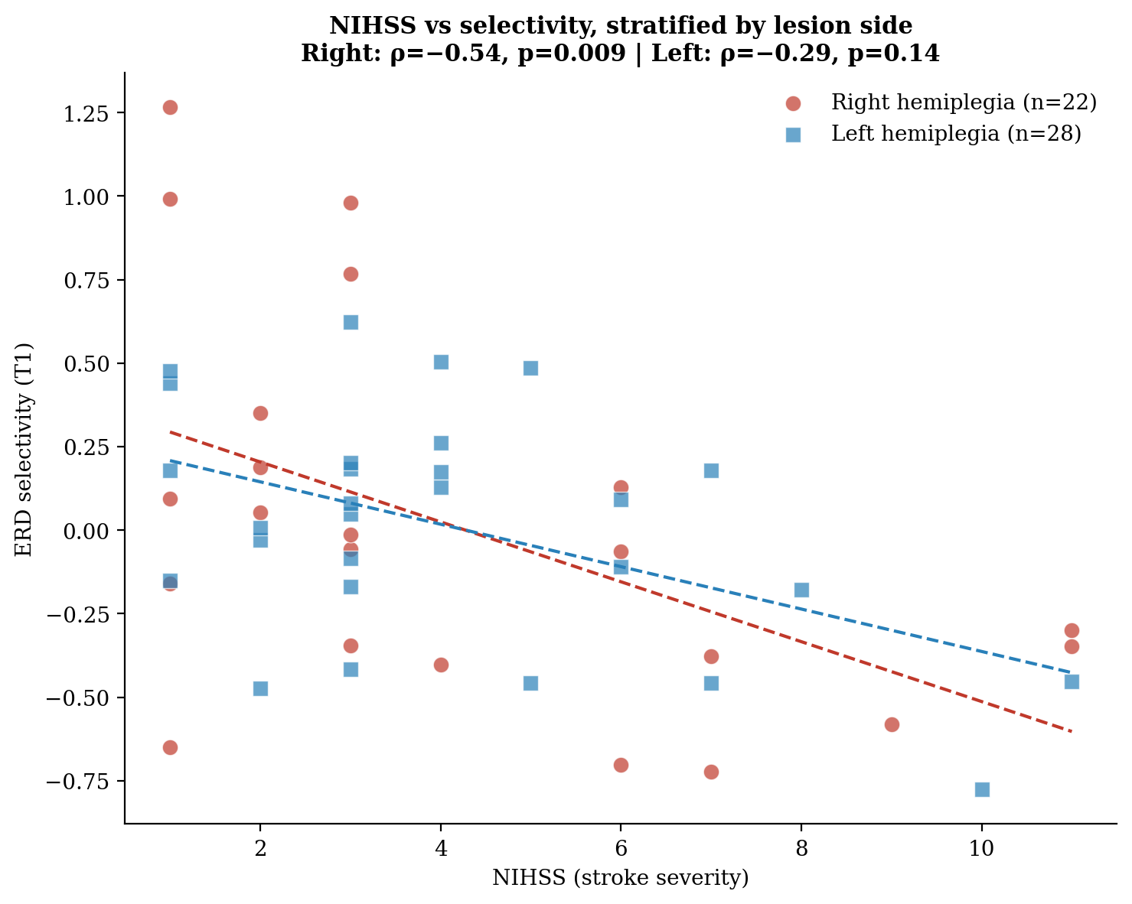
Figure 4. Clinical anchoring of selectivity to stroke severity, stratified by lesion side. ERD selectivity for the left-hand task (T1) plotted against NIHSS in the Liu 2024 stroke cohort, separated into right-hemiplegia (left-hemisphere lesion, n=22) and left-hemiplegia (right-hemisphere lesion, n=28) subgroups, with per-group least-squares fits. The NIHSS–selectivity relationship was significant in right-hemiplegia patients (ρ = −0.54, p = 0.009) but not left-hemiplegia patients (ρ = −0.29, p = 0.14), consistent with the interhemispheric competition account: T1 engages the right hemisphere, which is intact in right-hemiplegia patients.
3.5.2 Sensitivity analysis
Excluding 13 high-artefact subjects (n=37): selectivity–ΔLI preserved (T1 ρ = 0.77; T2 ρ = 0.95). NIHSS–selectivity weakened but remained significant (T1: ρ = −0.327, p = 0.048). Artefact-excluded subjects had balanced NIHSS profiles (clean: 4.14 vs excluded: 4.23) and a higher positive-ΔLI rate (76.9% vs 67.6%), ruling out systematic bias.
3.6 Dose-response dynamics
Within-session trajectory non-monotonicity ranged from 48.9% to 88.0%. BCI-IV-2b five-session BIC comparisons were equivocal (|ΔBIC| < 2 in 88% of subjects); the three-phase model is hypothesis-generating.
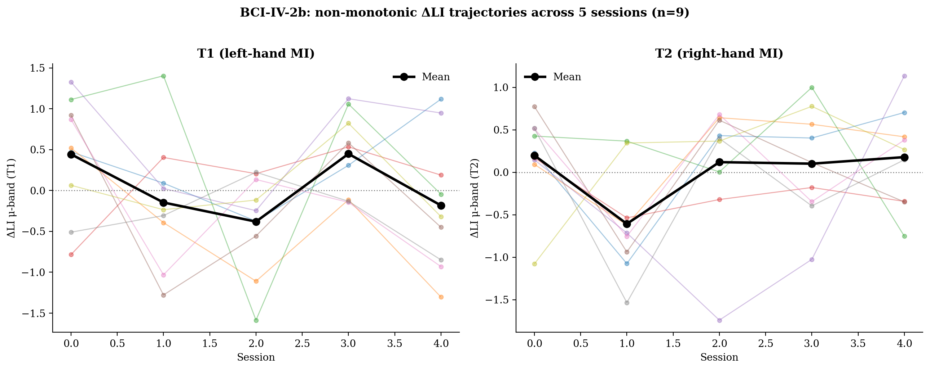
Figure 5. Within-participant ΔLI trajectories across sessions in the BCI-IV-2b cohort. Session-by-session μ-band ΔLI for the nine participants across five sessions, for the left-hand task (T1, left panel) and right-hand task (T2, right panel); individual participants are shown in faint colour and the group mean in bold black. Trajectories are predominantly non-monotonic (reversing direction between consecutive sessions), consistent with labile early-phase plasticity that requires repeated selective activation to consolidate.

3.7 Machine learning prediction
A gradient-boosting classifier trained on pooled healthy features (n=258, 10 features) predicted stroke ΔLI direction with AUC = 0.92 (Table 3). ERD selectivity was the dominant feature (T1: 29.5%, T2: 29.0% combined importance). Compared to a naive baseline that classifies all stroke patients as responders (accuracy = 70%, specificity = 0%), the model substantially improved specificity to 66.7% (correctly identifying 10 of 15 non-responders) while maintaining 97.1% sensitivity (34 of 35 responders correctly identified). The negative predictive value of 90.9% indicates that patients classified as non-responders by the model have a high probability of genuinely not responding, supporting its utility as a screening tool for treatment allocation.

Table 3a. Cross-population prediction performance.
Evaluation | AUC | Sens | Spec | PPV | NPV | n(train/test)
Cross-pop (healthy→stroke, GB) | 0.92 | 0.97 | 0.67 | 0.87 | 0.91 | 258/50
Naive baseline (all responders) | - | 1.00 | 0.00 | 0.70 | - | -/50

Table 3a. Cross-population classifier trained on pooled healthy subjects (n=258) and tested on the stroke cohort (n=50). The gradient-boosting (GB) model improves specificity from 0% (naive baseline) to 67% while retaining 97% sensitivity. Sens, sensitivity; Spec, specificity; PPV/NPV, positive/negative predictive value.

Table 3b. Within-dataset prediction performance.
Dataset | Model | AUC | n
PhysioNet 5-fold (GB) | GB | 0.87 | 108
Lee 2019 5-fold (GB) | GB | 0.87 | 53
BCI-IV-2b 5-fold (LR) | LR | 0.75 | 45
Liu 2024 5-fold (LR) | LR | 0.83 | 50
Cho 2017 5-fold (GB) | GB | 0.61 | 52†
Table 3b. Within-dataset 5-fold stratified cross-validation, best model per dataset shown (GB, gradient boosting; LR, logistic regression). Only AUC is reported, as threshold-dependent metrics are unstable across small folds. Cho 2017 is near chance owing to extreme class imbalance (6 non-responders).

4. Discussion
4.1 Selectivity versus static laterality: a mechanistic distinction
The central advance of this study is the identification of ERD lateralisation selectivity — the rate of lateralised ERD growth over training — as the dominant predictor of neuroplastic reorganisation. Crucially, selectivity does not describe a fixed anatomical bias; it captures neuroplasticity as it is being induced, in real time, across the training session. This is mechanistically distinct from the static laterality measures used in prior BCI research. ^{10,15,40,41} Static LI measures how lateralised a participant's brain is at a given moment — a snapshot of existing balance — whereas selectivity measures how rapidly that balance is being reshaped as the participant trains. The empirical distinction is stark: static LI showed no relationship with ΔLI (PhysioNet ρ = 0.09; Liu 2024 ρ = −0.14), while selectivity predicted strongly (PhysioNet ρ = 0.84; Liu 2024 ρ = 0.81). A participant with high baseline laterality but no further shift has high static LI yet zero selectivity and zero ΔLI: an already-lateralised brain that is not currently changing. Selectivity instead tracks the live, learning-dependent process — the progressive, trial-by-trial accumulation of contralateral gain that reflects activity-dependent synaptic strengthening as it unfolds. In this sense the metric does not merely correlate with reorganisation; it indexes the ongoing neuroplastic event itself.
The bilateral null (all |ρ| < 0.20, 12/12 tests) further distinguishes selectivity from generic signal quality or arousal confounds, all of which would produce bilateral effects. The cross-band null (μ-selectivity does not predict β-ΔLI) confirms frequency-specificity. Together, these controls demonstrate that selectivity measures a genuine, band-specific neuroplastic process rather than a mathematical artefact of the LI computation.
The molecular basis for why selectivity — rather than total activation — determines neuroplastic outcome can be understood through the synaptic tagging and capture framework (Frey and Morris, 1997). Early-phase LTP (E-LTP) is induced at any synapse receiving sufficient activation, is protein synthesis-independent, and decays within 1–3 hours (Malenka and Bear, 2004; Lisman et al., 2002). Consolidation into late-phase LTP (L-LTP) requires capture of plasticity-related proteins — including BDNF, Arc/Arg3.1, and newly synthesised AMPA receptors — at synapses tagged by prior activation. When MI-induced ERD is bilateral (diffuse), tags are set at both contralateral and ipsilateral sensorimotor synapses, and the finite pool of plasticity-related proteins is divided across both hemispheres, diluting the consolidation signal below the threshold for stable L-LTP. When ERD is selective (contralateral-dominant), tags are concentrated at contralateral synapses, and proteins are captured efficiently, maximising consolidation into durable reorganisation. This provides a molecular explanation for the bilateral null: diffuse activation induces E-LTP widely but consolidates it nowhere, while selective activation induces E-LTP focally and consolidates it into the ΔLI shift. The within-session timescale of tercile-based ΔLI measurement (5–15 minutes) is consistent with E-LTP induction and early consolidation dynamics, while the cross-session replication in BCI-IV-2b suggests repeated selective activation produces cumulative L-LTP consolidation consistent with the BDNF-dependent late phase.
This consolidation framework clarifies an otherwise puzzling feature of the data: the high rate of non-monotonic ΔLI trajectories even among participants who ultimately reorganised. Across healthy cohorts, 49–67% of subjects showed a direction reversal between consecutive training stages, and 64% of healthy responders reversed at least once before reaching a net positive ΔLI. Rather than indicating noise, these reversals are consistent with the labile nature of early-phase plasticity: E-LTP induced during one phase of training decays within 1–3 hours unless captured into L-LTP, so a lateralisation gain established early can be lost before the session ends if consolidation is incomplete. Reorganisation is therefore not a monotonic accrual but a competition between repeated selective induction and ongoing decay, with durable ΔLI emerging only when selective activation is sustained densely enough to drive protein capture before the E-LTP window closes. This reframes the reversibility of MI-BCI plasticity as an intrinsic property of the induction–consolidation dynamic, not a measurement limitation, and predicts that protocols spacing selective activation to match the L-LTP consolidation window would convert transient gains into stable reorganisation.
This framework also explains the elevated trajectory instability observed in stroke. Non-monotonic ΔLI trajectories — in which lateralisation shifts in one direction between early and mid training, then reverses between mid and late — were markedly more frequent in the stroke cohort (88.0% for T1) than in healthy cohorts (48.9–67.3%). Critically, this instability persisted even among stroke responders: 87% of stroke patients who achieved a net positive ΔLI nonetheless showed a mid-trajectory reversal, versus 64% of healthy responders. We interpret these reversals as the EEG signature of E-LTP induction that fails to consolidate into L-LTP. The peri-infarct molecular environment is hostile to consolidation: elevated tonic GABA, impaired BDNF–TrkB signalling, and disrupted interhemispheric inhibition all lower the probability that activation-tagged synapses successfully capture plasticity-related proteins ^{(28,29)}. Selective contralateral activation may be induced session-to-session, but without efficient protein capture it decays before stabilising — producing the reversals seen here and explaining why stroke responder rates are lower (70.0% vs 79.5%) despite comparable capacity to engage the cortex. The contribution of our findings is to make this otherwise hidden failure directly measurable. Because selectivity indexes lateralised induction in real time and ΔLI tracks whether it consolidates, the two together expose precisely where the consolidation constraint breaks down — distinguishing a patient who cannot induce selective activation from one who induces it but fails to retain it. Conventional magnitude-based or endpoint metrics cannot separate these cases; both simply appear as "non-responders." Our framework therefore converts an opaque clinical failure into an observable, stage-specific target: reversals flag patients whose plasticity is induced but not stabilised, identifying exactly when a consolidation-directed intervention (e.g. spaced training matched to the L-LTP window, or adjuvant neuromodulation) should be applied. The gate can open but not stay open — and selectivity is what lets us see, session by session, whether it has.
4.2 From five candidates to three validated mechanisms
Multi-cohort validation invalidated trial-level ERD stability and temporal precision at within-session timescales. Three mechanisms survived with distinct roles. ERD selectivity is the dominant predictor with immediate screening utility. Interhemispheric competition did not add independent within-cohort variance, but provides the mechanistic bridge: the NIHSS–selectivity correlation being driven by right-hemiplegia patients is precisely the pattern predicted by the interhemispheric competition framework.^{28,29,35} μ–β coordination provides phenotypic stratification.
4.3 The responder definition problem
The conventional MI-BCI 'responder' classification — ≥70% binary accuracy^{30,31} — is paradigm-dependent.^{32,33} Our permutation analysis confirms that per-task ΔLI > 0 does not exceed chance, and that the continuous selectivity–ΔLI relationship (ρ = 0.76–0.96) is the appropriate level of analysis.
4.4 Dose-response: hypothesis-generating
BCI-IV-2b five-session trajectories showed non-monotonic ΔLI accumulation, but BIC comparisons were equivocal (n=9). The three-phase model is presented as a hypothesis for purpose-designed longitudinal studies.
4.5 Clinical translation
The cross-population model (AUC = 0.92) correctly identified 10 of 15 non-responders (specificity = 66.7%) while missing only 1 of 35 responders (sensitivity = 97.1%). This is a clinically meaningful improvement over naive classification, which identifies zero non-responders: the model flags two-thirds of patients unlikely to benefit while almost never excluding one who would. However, one-third of non-responders (5/15) are still misclassified as responders, so the model should augment rather than replace clinical judgment.
4.6 Comparison with competing stroke biomarkers
DTI fractional anisotropy predicts motor recovery after BCI intervention,³⁷ but requires MRI and has been validated in only one BCI cohort (n=13). TMS motor evoked potentials are the strongest predictor of general motor recovery,^{38,42} but assess excitability rather than lateralisation and are unobtainable in severely affected patients.³⁹
The practical translational advantage of EEG-based selectivity over fMRI-based laterality is fundamental. fMRI laterality index, while the gold standard for measuring cortical reorganisation (Ramos-Murguialday et al., 2013),40,41 is a retrospective correlate: it confirms that reorganisation occurred after training is complete, but cannot guide real-time clinical decisions. EEG selectivity is a prospective predictor: computed from a 3-electrode montage in 10 minutes, it can be assessed before training begins (for patient stratification), during training (for dose adjustment), and between sessions (for progress monitoring). This positions selectivity not as an alternative measurement of the same construct, but as the clinical-grade operationalisation of a mechanistic principle that fMRI identified but could not make actionable. In rehabilitation settings without neuroimaging infrastructure — which serve the majority of the global stroke population — EEG-based assessment represents the most practical pathway for implementing neuroplasticity-guided treatment stratification.
A minimal EEG montage (3 electrodes) with standard amplification hardware is orders of magnitude less expensive than MRI or TMS infrastructure, requires no specialist operator, and can be administered by a trained physiotherapist in any clinical setting. This positions selectivity-based screening as feasible in rehabilitation contexts where neuroimaging and neuromodulation facilities are unavailable. These biomarkers are complementary: DTI-FA indexes structural tract integrity, TMS-MEPs index descending excitability, fMRI-LI indexes haemodynamic lateralisation, and EEG selectivity indexes real-time oscillatory lateralisation dynamics. None of the competing biomarkers have been validated across five independent datasets with cross-population transfer. Head-to-head comparison within the same cohort is a priority for the proposed Phase II trial.

5. Clinical Implications
The selectivity principle implies three immediate clinical applications.
First, a fundamental modification to MI-BCI feedback algorithms. Current protocols reward total ERD magnitude — maximising cortical activation regardless of its hemispheric distribution. The present findings suggest that feedback should instead be contingent on the lateralised component of ERD (contralateral minus bilateral), rewarding selective rather than diffuse activation. This is implementable in existing BCI systems through a software update to the feedback contingency calculation, requiring no new hardware.
Second, a three-tier patient stratification protocol: (i) High-selectivity patients (above median at screening) proceed with standard MI-BCI training at standard dose; (ii) Moderate-selectivity patients receive selectivity coaching — kinesthetic imagery training with lateralised feedback contingency, optionally augmented with ipsilesional tDCS to enhance contralateral M1 excitability; (iii) Low-selectivity patients (below threshold, corresponding to high NIHSS in right-hemiplegia patients) are deferred from MI-BCI and directed toward alternative rehabilitation approaches until selectivity improves or an augmentation strategy demonstrates threshold-crossing. This triage capability addresses the 15–30% non-response rate: rather than applying uniform training and discovering non-response after weeks of therapy, a 10-minute selectivity screen identifies candidates for protocol modification before training begins.
Third, a Phase II RCT to validate this framework: stratify by baseline selectivity (median split), randomise to standard MI-BCI vs selectivity-optimised MI-BCI (lateralised feedback + ipsilesional tDCS), compare ΔLI and Fugl-Meyer UE at 3 and 6 months. Primary outcome: continuous ΔLI. Secondary: NIHSS change, FMA-UE, fMRI-LI.
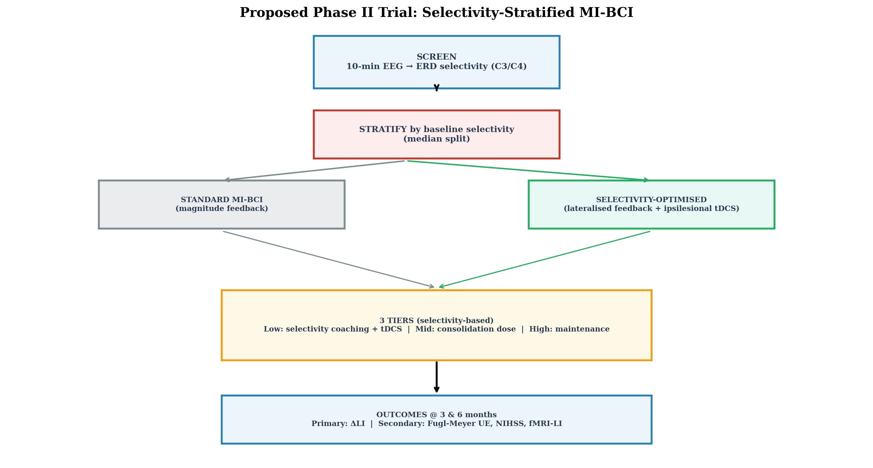
Figure 7. Proposed Phase II trial design. A schematic of the selectivity-stratified MI-BCI protocol: a 10-minute EEG screen computes ERD selectivity from C3/C4, participants are stratified by baseline selectivity (median split) and randomised to standard (magnitude-feedback) or selectivity-optimised (lateralised-feedback plus ipsilesional tDCS) MI-BCI, with a three-tier intervention pathway and ΔLI as the primary outcome alongside Fugl-Meyer upper-extremity, NIHSS, and fMRI laterality index as secondary outcomes at 3 and 6 months.

6. Limitations
Five limitations constrain these conclusions. First, ΔLI is a session-level measure, not a stable trait, so its low between-session magnitude reliability (ICC = 0.04, BCI-IV-2b) reflects genuine session-to-session variation in plasticity dynamics rather than measurement error. That this reflects signal, not noise, is supported by two observations: the direction of ΔLI was consistent across sessions (sign consistency = 0.71, chance = 0.50), and the selectivity–ΔLI relationship replicated in every dataset regardless of session structure. Both estimates derive from 9 subjects and should be read as indicative rather than definitive.Second, the clinical anchor is task-specific (T1 only) and lesion-side-specific (right hemiplegia only), which is neurophysiologically interpretable (T1 engages the intact hemisphere in right-hemiplegia patients) but limits generalisation until validated with the paretic-hand task. The NIHSS–selectivity correlation is borderline in the artefact-excluded subsample (ρ = −0.327, p = 0.048, n=37). Third, the model's specificity (66.7%) means roughly one-third of non-responders are misclassified as responders; it is therefore best deployed as a decision-support tool that complements clinical assessment, prioritising near-complete sensitivity (97%) so that few treatable patients are wrongly excluded.
7. Ethics Statement
This study is a used five publicly available, fully de-identified EEG datasets; no new data were collected and no additional ethics approval was required. Each original study obtained ethics approval from the relevant institutional review board and informed consent from participants, as reported in the respective source publications.
8. Data and Code Availability
All datasets are publicly available: PhysioNet EEGMMIDB, Cho 2017 (GigaDB), BCI-IV-2b (BNCI Horizon 2020), Lee 2019 (GigaDB/OpenBMI), Liu 2024 (figshare, doi:10.6084/m9.figshare.21679035). Analysis code will be deposited upon acceptance.

9. References
1. Pfurtscheller G, Lopes Da Silva FH. Event-related EEG/MEG synchronization and desynchronization: basic principles. Clin Neurophysiol. 1999;110(11):1842-1857. doi:10.1016/S1388-2457(99)00141-8
2. Schalk G, McFarland DJ, Hinterberger T, Birbaumer N, Wolpaw JR. BCI2000: A General-Purpose Brain-Computer Interface (BCI) System. IEEE Trans Biomed Eng. 2004;51(6):1034-1043. doi:10.1109/TBME.2004.827072
3. Tibrewal N, Leeuwis N, Alimardani M. Classification of motor imagery EEG using deep learning increases performance in inefficient BCI users. Mian Qaisar S, ed. PLOS ONE. 2022;17(7):e0268880. doi:10.1371/journal.pone.0268880
4. Cervera MA, Soekadar SR, Ushiba J, et al. Brain‐computer interfaces for post‐stroke motor rehabilitation: a meta‐analysis. Ann Clin Transl Neurol. 2018;5(5):651-663. doi:10.1002/acn3.544
5. Bai Z, Fong KNK, Zhang JJ, Chan J, Ting KH. Immediate and long-term effects of BCI-based rehabilitation of the upper extremity after stroke: a systematic review and meta-analysis. J NeuroEngineering Rehabil. 2020;17(1):57. doi:10.1186/s12984-020-00686-2
6. Gaughan TCLS, Boe SG. Investigating the dose‐response relationship between motor imagery and motor recovery of upper‐limb impairment and function in chronic stroke: A scoping review. J Neuropsychol. 2022;16(1):54-74. doi:10.1111/jnp.12261
7. Pichiorri F, Morone G, Petti M, et al. Brain–computer interface boosts motor imagery practice during stroke recovery. Ann Neurol. 2015;77(5):851-865. doi:10.1002/ana.24390
8. Sebastián-Romagosa M, Udina E, Ortner R, et al. EEG Biomarkers Related With the Functional State of Stroke Patients. Front Neurosci. 2020;14:582. doi:10.3389/fnins.2020.00582
9. Colucci A, Vermehren M, Cavallo A, et al. Brain–Computer Interface-Controlled Exoskeletons in Clinical Neurorehabilitation: Ready or Not? Neurorehabil Neural Repair. 2022;36(12):747-756. doi:10.1177/15459683221138751
10. Kasahara K, DaSalla CS, Honda M, Hanakawa T. Neuroanatomical correlates of brain–computer interface performance. NeuroImage. 2015;110:95-100. doi:10.1016/j.neuroimage.2015.01.055
11. Lee MH, Kwon OY, Kim YJ, et al. EEG dataset and OpenBMI toolbox for three BCI paradigms: an investigation into BCI illiteracy. GigaScience. 2019;8(5):giz002. doi:10.1093/gigascience/giz002
12. Mohanty R, Sinha AM, Remsik AB, et al. Machine Learning Classification to Identify the Stage of Brain-Computer Interface Therapy for Stroke Rehabilitation Using Functional Connectivity. Front Neurosci. 2018;12:353. doi:10.3389/fnins.2018.00353
13. Zanona ADF, Piscitelli D, Seixas VM, et al. Brain-computer interface combined with mental practice and occupational therapy enhances upper limb motor recovery, activities of daily living, and participation in subacute stroke. Front Neurol. 2023;13:1041978. doi:10.3389/fneur.2022.1041978
14. Ma ZZ, Wu JJ, Hua XY, et al. Evidence of neuroplasticity with brain–computer interface in a randomized trial for post-stroke rehabilitation: a graph-theoretic study of subnetwork analysis. Front Neurol. 2023;14:1135466. doi:10.3389/fneur.2023.1135466
15. Ferrero L, Ortiz M, Quiles V, Iáñez E, Flores JA, Azorín JM. Brain Symmetry Analysis during the Use of a BCI Based on Motor Imagery for the Control of a Lower-Limb Exoskeleton. Symmetry. 2021;13(9):1746. doi:10.3390/sym13091746
16. Mrachacz-Kersting N, Jiang N, Stevenson AJT, et al. Efficient neuroplasticity induction in chronic stroke patients by an associative brain-computer interface. J Neurophysiol. 2016;115(3):1410-1421. doi:10.1152/jn.00918.2015
17. Bramham CR, Messaoudi E. BDNF function in adult synaptic plasticity: The synaptic consolidation hypothesis. Prog Neurobiol. 2005;76(2):99-125. doi:10.1016/j.pneurobio.2005.06.003
18. Panja D, Bramham CR. BDNF mechanisms in late LTP formation: A synthesis and breakdown. Neuropharmacology. 2014;76:664-676. doi:10.1016/j.neuropharm.2013.06.024
19. Lynch MA. Long-Term Potentiation and Memory. Physiol Rev. 2004;84(1):87-136. doi:10.1152/physrev.00014.2003
20. Cantarero G, Tang B, O’Malley R, Salas R, Celnik P. Motor Learning Interference Is Proportional to Occlusion of LTP-Like Plasticity. J Neurosci. 2013;33(11):4634-4641. doi:10.1523/JNEUROSCI.4706-12.2013
21. Nierhaus T, Vidaurre C, Sannelli C, Mueller K, Villringer A. Immediate brain plasticity after one hour of brain–computer interface (BCI). J Physiol. 2021;599(9):2435-2451. doi:10.1113/JP278118
22. Cantillo-Negrete J, Carino-Escobar RI, Carrillo-Mora P, et al. Brain-Computer Interface Coupled to a Robotic Hand Orthosis for Stroke Patients’ Neurorehabilitation: A Crossover Feasibility Study. Front Hum Neurosci. 2021;15:656975. doi:10.3389/fnhum.2021.656975
23. Chen S, Chen M, Wang X, Liu X, Liu B, Ming D. Brain–computer interfaces in 2023–2024. Brain‐X. 2025;3(1):e70024. doi:10.1002/brx2.70024
24. Vidaurre C, Sannelli C, Müller KR, Blankertz B. Co-adaptive calibration to improve BCI efficiency. J Neural Eng. 2011;8(2):025009. doi:10.1088/1741-2560/8/2/025009
25. Cho H, Ahn M, Ahn S, Kwon M, Jun SC. EEG datasets for motor imagery brain–computer interface. GigaScience. 2017;6(7):gix034. doi:10.1093/gigascience/gix034
26. Jayaram V, Barachant A. MOABB: trustworthy algorithm benchmarking for BCIs. J Neural Eng. 2018;15(6):066011. doi:10.1088/1741-2552/aadea0
27. Liu H, Wei P, Wang H, et al. An EEG motor imagery dataset for brain computer interface in acute stroke patients. Sci Data. 2024;11(1):131. doi:10.1038/s41597-023-02787-8
28. Murase N, Duque J, Mazzocchio R, Cohen LG. Influence of interhemispheric interactions on motor function in chronic stroke. Ann Neurol. 2004;55(3):400-409. doi:10.1002/ana.10848
29. Di Pino G, Pellegrino G, Assenza G, et al. Modulation of brain plasticity in stroke: a novel model for neurorehabilitation. Nat Rev Neurol. 2014;10(10):597-608. doi:10.1038/nrneurol.2014.162
30. Blankertz B, Sannelli C, Halder S, et al. Neurophysiological predictor of SMR-based BCI performance. NeuroImage. 2010;51(4):1303-1309. doi:10.1016/j.neuroimage.2010.03.022
31. Sannelli C, Vidaurre C, Müller KR, Blankertz B. A large scale screening study with a SMR-based BCI: Categorization of BCI users and differences in their SMR activity. Ayaz H, ed. PLOS ONE. 2019;14(1):e0207351. doi:10.1371/journal.pone.0207351
32. Thompson MC. Critiquing the Concept of BCI Illiteracy. Sci Eng Ethics. 2019;25(4):1217-1233. doi:10.1007/s11948-018-0061-1
33. Allison BZ, Neuper C. Could Anyone Use a BCI? In: Tan DS, Nijholt A, eds. Brain-Computer Interfaces. Human-Computer Interaction Series. Springer London; 2010:35-54. doi:10.1007/978-1-84996-272-8_3
34. Ahn M, Cho H, Ahn S, Jun SC. High Theta and Low Alpha Powers May Be Indicative of BCI-Illiteracy in Motor Imagery. Hu D, ed. PLoS ONE. 2013;8(11):e80886. doi:10.1371/journal.pone.0080886
35. Hummel FC, Cohen LG. Non-invasive brain stimulation: a new strategy to improve neurorehabilitation after stroke? Lancet Neurol. 2006;5(8):708-712. doi:10.1016/S1474-4422(06)70525-7
36. Shu X, Chen S, Yao L, et al. Fast Recognition of BCI-Inefficient Users Using Physiological Features from EEG Signals: A Screening Study of Stroke Patients. Front Neurosci. 2018;12:93. doi:10.3389/fnins.2018.00093
37. Song J, Nair VA, Young BM, et al. DTI measures track and predict motor function outcomes in stroke rehabilitation utilizing BCI technology. Front Hum Neurosci. 2015;9. doi:10.3389/fnhum.2015.00195
38. Bembenek JP, Kurczych K, Karli Nski M, Czlonkowska A. The prognostic value of motor-evoked potentials in motor recovery and functional outcome after stroke − a systematic review of the literature. Funct Neurol. 2012;27(2):79-84.
39. Stinear CM, Barber PA, Smale PR, Coxon JP, Fleming MK, Byblow WD. Functional potential in chronic stroke patients depends on corticospinal tract integrity. Brain. 2006;130(1):170-180. doi:10.1093/brain/awl333
40. Ramos‐Murguialday A, Broetz D, Rea M, et al. Brain–machine interface in chronic stroke rehabilitation: A controlled study. Ann Neurol. 2013;74(1):100-108. doi:10.1002/ana.23879
41. Ramos-Murguialday A, Curado MR, Broetz D, et al. Brain-Machine Interface in Chronic Stroke: Randomized Trial Long-Term Follow-up. Neurorehabil Neural Repair. 2019;33(3):188-198. doi:10.1177/1545968319827573
42. Milot MH, Spencer SJ, Chan V, et al. Corticospinal Excitability as a Predictor of Functional Gains at the Affected Upper Limb Following Robotic Training in Chronic Stroke Survivors. Neurorehabil Neural Repair. 2014;28(9):819-827. doi:10.1177/1545968314527351
43. Frey U, Morris RGM. Synaptic tagging and long-term potentiation. Nature. 1997;385(6616):533-536. doi:10.1038/385533a0
44. Malenka RC, Bear MF. LTP and LTD. Neuron. 2004;44(1):5-21. doi:10.1016/j.neuron.2004.09.012
45. Lisman J, Schulman H, Cline H. The molecular basis of CaMKII function in synaptic and behavioural memory. Nat Rev Neurosci. 2002;3(3):175-190. doi:10.1038/nrn753

